**Workshop 10: Worst-Case Analysis**

LI LIPING (A0186040M) ZHANG AO (A0176595L) WANG XINRUI (A0186103M)

**Task 2**

In workshop 6 we have analyzed the feed mix problem. Download the file “feed_mix.gms” and adapt it to performance risk analysis over the feeding cost. The price variances and correlation matrix are in the gams file.

*A)  Include the code to generate correlated feed prices. Assume Barley as the “indexfeed”.*

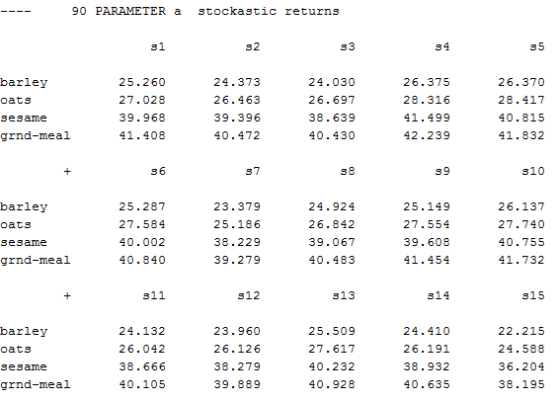

Figure 1 Correlated Feed Prices

The above graph shows the price for 4 kinds of commodities in 15 iterations.

[correction: sum((f,s), prot(s,f)*x(f))/card(s) =g= req(n)]

*B)  Modify the constraints to compute the CVAR and compute the optimal policy.*

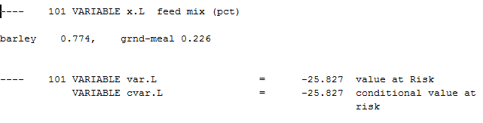

Figure 2 CVaR Result

As the graph shown above, the optimal policy is to spend 77.4% budget buying *barley* and 22.6% buying *grnd_meal*. The corresponding conditional value at risk is -25.827.

*C)  Modify the constraints to compute the Worst-Case analysis and compute the optimal policy.*

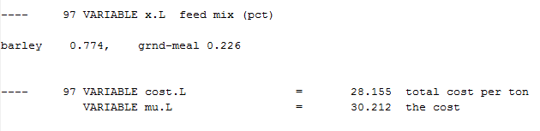

Figure 3 Worst-Case Analysis

We modified the constraint and set new variable *mu* greater or equal to two kinds of cost. The optimal policy stays the same with part(b). The objective min (max *mu*) in the Worst-Case analysis is 30.212.

*D)  Compare the results obtained from your analysis in B), C) and the risk-neutral policy (obtained from the original program).*

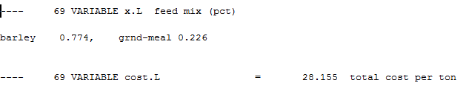

Figure 4 Results Comparison

The optimal policy keeps the same while we modified the constraint. However, CVaR in part(b) is lower than the ones in the other two parts.

We also change the requirements of protein from 21 to 30 and fats from 5 to 50. Then we increase the scenario from 100 to 1000. The final result is shown below, here we will use 5.3% to buy barley and the rest to buy grnd-meal.

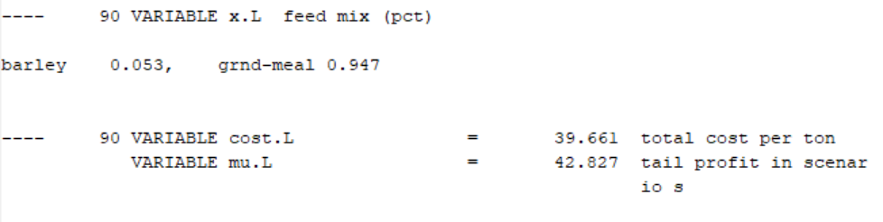

Figure 5 Results Comparison

**Task 1**

You were asked to re-analyze the portfolio management problem by using worst-case analysis. What is the optimal policy? How does it compare with optimal policy derived for CV@R optimization? What is the respective expected profit and CV@aR?

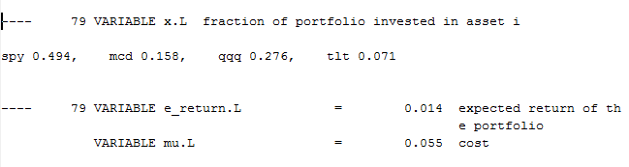

The optimal policy is to invest 49.4% on spy, 15.8% on mcd, 27.6% on qqq and 7.1% on tlt, the worst case expected return is 5.5%

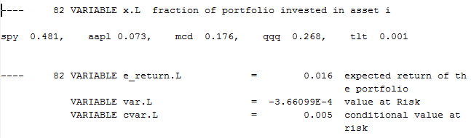

The optimal policy is to invest 48.1% on spy, 17.6% on mcd, 26.8% on qqq, 7.3% on aapl, and 0.1% on tlt. The expected return is 1.6%.